PODCAST Media Tool Kit for January 2025 FarmSafe Bundle Drop
Text to include in a NEWSLETTER: Please use the information below to send information on the FarmSafe Podcast to your partners via email. Yellow highlighted text is informational only and should be cut when sending out information that follows.
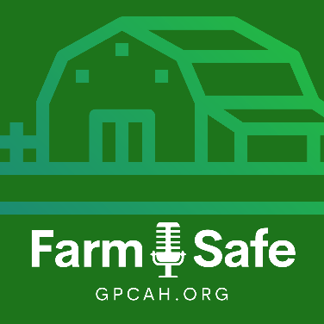
Newsletter Article
The Great Plains Center for Agricultural Health has dropped new FarmSafe Podcast episodes. The mission of the podcast is to enhance agricultural safety and health, and these episodes bring in new partners to discuss important messages about preventing injury and illness on the farm.
Explore Our New Podcast Episodes
In Season 4, our first bundle dropped in January. These five episodes cover topics related to how messaging impacts perceptions of safety, ways to minimize fire risks, understanding medication-related fall risks, and how to approach succession planning to minimize mental stress. The final episode discusses safety for youth living and working on the farm.
- S4E2 | “Farming the Message: Reporting Agricultural Incidents” – Explores the important role that terminology plays in how agricultural injuries and fatalities are reported in the media. With expert guests, Dr. Barbara Lee and Melissa Ploeckelman
- S4E3 | “Burning Issues: Fire Safety on Farms” – Discusses the unique fire risks that farmers face and offers expert advice on how to minimize those dangers. With expert guest, Jerry Minor, Chief of the Pittsville Fire Department.
- S4E4 | “Falls on Farms: The Medication Connection” – Delves into the issue of medication-related falls among farmers, highlighting the risks that medications pose when mixed with the physically demanding nature of farming. With expert guest, Dr. Ryan Carnahan.
- S4E5 | “The Seed of Success: Growing Your Farm’s Future” – Provides expert advice on navigating the often complex process of transferring farm ownership and leadership to the next generation and how to address the stressors of succession planning. With expert guest, Joy Kirkpatrick.
- S4E6 | “The Farm-Kid Paradox” – Discusses the significance of age-appropriate tasks, best practices for educating young farm workers, and proper supervision while fostering a positive farm experience for children and youth who are living and working on the farm. With expert guests, Dr. Barbara Lee and Melissa Ploeckelman.

Each episode features expert interviews, personal experiences from farmers, and practical advice with the goal of preventing injuries, improving health outcomes, and raising awareness of important agricultural health and safety hazards.
We hope you can listen and share these new episodes with those dedicated to creating safer, healthier environments on the farm. Reach out via cph-greatplainscenter@uiowa.edu your ideas for new episodes.

To view all FarmSafe Podcast episodes, scan the QR Code, or visit https://gpcah.public-health.uiowa.edu/farmsafe/

